From Rojava to Hamburg: Fight G-20
Posted on June 15, 2017

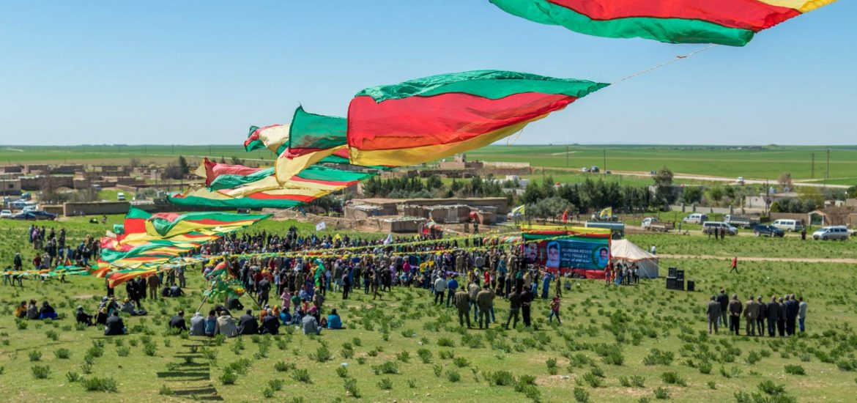

To our companions, friends and comrades,
To borrow some words from the Zapatistas:
What we learned is, that from above comes only exploitation, robbery, oppression and disdain. This means, that from above comes only pain
On the 7th and 8th of July, the representatives of this world of pain and of killing for profit and power will meet in Hamburg. The world they want to preserve is dystopic. It‘s a world of F16-Bombers and combat drones, a world of patriarchal opression, of spying and brutal exploitation.
Their world of capital, nation state and patriarchy is in a deep long lasting crisis: economically as well as politically but also concerning their ideological legitimacy.
Today, fewer and fewer people believe that we live in the best of all possible worlds.
Our quest for a different world brought us to the liberated territories of the middle east – the revolution in rojava today embodies the spirit of resistance against their malicious world.. The revolution happening in Kurdistan right now is our Revolution and part of our search.
Our search for what could be possible means accepting a rich heritage: the women of the Paris Commune of 1871 and the workers militias of the Hamburg uprising of 1923 – that’s us.
The comrades of the October Revolution and the Spanish War – that’s us.
The workers on strike in India and the guerrilla in the mountains of Kurdistan – that’s us.
We are the anarchists of Greece.
We are the witches and the rebellious farmers of the early modern period and the poor in the consejos communales of Venezuela.
We are squatters just as we are the Foodora and Deliveroo drivers on strike.
We who are working here in Rojava as internationalists are part of the worldwide fight of the oppressed against the reign of state, capital and patriarchy just as you are today in Hamburg.
Here in northern Syria we have the space to prove in practice that we can organize by our own power and build a better world. We take part in the different sectors of the revolution: We see education and work in the communes, cooperatives and neighborhoods; we discuss and learn, we build houses and plant trees; we take part in the self-defense of the revolution against the murderers who want to suffocate it.
The summit of the G20 is a meeting of the enemies of this revolutionary project. The actors of the capitalist world of opression meeting in Hamburg embody everything that we oppose: From Trump to Erdogan, from Merkel the the Saudis, from Putin to Macron. This is why we are very happy about the fires of resistance that you want to light in the streets of Hamburg and in the hearts of those that want to shatter their chains. The light of these fires shines AL the way to the freed cantons.
Our resistance needs a long term perspective. That includes ourselves becoming militant personalities, letting our strength grow, and learning the truth about the revolutionary struggle. This also means overcoming the culture of dominance, the traces that were left by patriarchy, a capitalist lifestyle and the mentality of the nation-state have left in us.
Rojava is a good school. Here we cannot only learn how to be an actual part of a movement and of a whole society. We teach ourselves in the arts of strengthening our unity and being diverse without falling into ideological randomness. In 1976 imprisoned comrades of the movement of 2nd of June wrote:
What has to matter for us now and today – if we do not want to dig a political mass grave for all of us– is to overcome our fragmentation and to see over the horizons of our small groups. While the left in this country is busy fighting each other, the rightwing is gathering to attack.
The protests against the G20 summit in Hamburg and the internationalist commune of Rojava are both part of the struggle to overcome this fragmentation.
The crisis of the hegemonic system produces monsters. The chaos it creates is a chaos that makes the reorganization of the ruling conditions possible. How this reorganization is going to look will be decided by the question of which force is best able to organize. Us, who as revolutionaries search for a way out, or those that give a reactionary, racist, chauvinist answer to the crisis?
If we want to be victorious we have to admit that our fight today is a fight for all or nothing. Today we wage a global struggle that will end either in liberation or in total oppression and has reached the level of a third world war.
We cannot take ourselves out of this and expect or hope that others will do what we are too lazy or too afraid to do.
It is the time of bravery and of decisions, the time of co-ordination and organization. It is the time of action.
We send you all our bravery and willpower, all our hatred for those that want to create a world of darkness and hopelessness. We send you all our love, you who fight with us and light the fires of resistance – in Hamburg and in Rojava.

Comment
July 19, 2017 at 7:47 am
Your comment is awaiting moderation.
Liebe Freunde !
1.Ihr bgeht m.E. einen sehr wichtigen Fehler wie viele Linke. Von unseren Feinden-den Imperialisten-gar nicht zu sprechen !!
Es gibt nämlich zweierlei von Staaten. Nämlich die sozialistischen und die kapitalistischen Staaten.
Und der Unterschied ist VOR ALLEM FÜR DIEJENIGEN VON UNS DEUTLICH DIE BEIDE REGIERUNGEN KENNENGELERNT HABEN !!
Die DDR z. B., inder ich aufwuchs, tat alles für das Wohl des Volkes. In jeder Lebenslage waren seine Bürger beschützt vom Staat. Heute regieren 600 reiche Familien die ganze Welt, welche VON ALLEN IMPERIALISTISCHEN STAATEN DER WELT GESCHÜTZT WERDEN:.
2. Beim G20 Treffen waren nicht nur imperialistische Staaten anwesend, sondern auch andere Staaten, an der Spitze China und Russland, die Schritt für Schritt einen anderen Weg der Entwicklung gehen. NICHT UMSONST WERDEN SIIE VON DEN US/NATO-STAATEN ANGEGRIFFEN !!
ICH HABE DEN VERDAMMTEN EINDRUCK, DASS BEI EUCH AM TISCH UND AN DER SPITZE DES KURDISCHEN ORGANISATIONSKOMITEES EINIGE LEUTE SITZEN, DIE EUCH LETZTENDLICH VERANLASSEN; MIT DENEN ZU KOOPERIEREN, DIE MIT EUCH NUR ZUSAMMENARBEITEN WOLLEN;UM GEGEN DIE STAATEN ZU KÄMPFEN, VON DENEN DIE HOFFNUNG FÜR DIE GANZE WELT AUSGEHT !!
Brigitte Queck, Dipl.Staatswissenschaftlerin Außenpolitik

Leave a Reply

Being part of the revolution
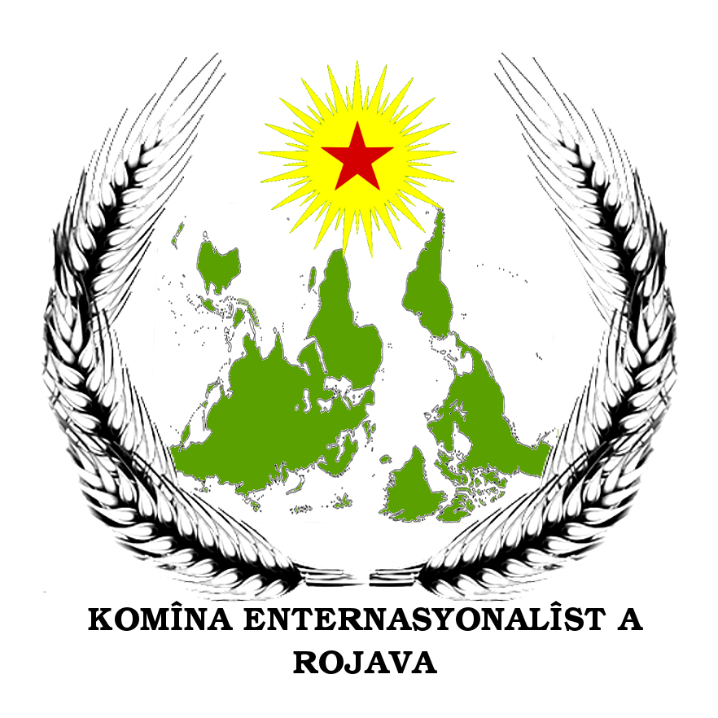

Free Öcalan
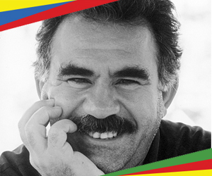

Newsletter

Your Email (required)

Contact
email: internationalistcommune(@)riseup.net

Social Media

