Nordkorea

Photo-Report: The North Korea Neither Trump Nor Western Media Wants The World To See
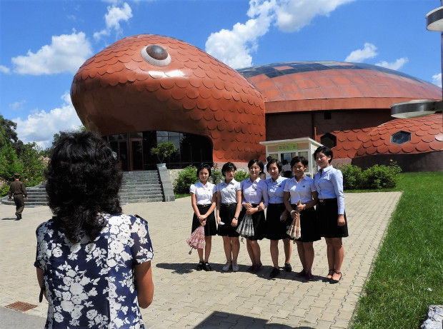
Photo © Eva Bartlett. A group of schoolgirls pause for a portrait photo at Pyongyang’s zoo. Watch a clip from the zoo.
October 20th, 2017
By Eva Bartlett
*all photos/videos by Eva Bartlett
PYONGYANG, NORTH KOREA — North Korea (the Democratic People’s Republic of Korea, or DPRK) is one of the least understood and most lied about countries on Earth. In Western corporate media renditions, most news about the country is alarmist (of “the North Koreans want to kill you” type), fake (“all men have to have the same haircut,” a story originating from Washington itself), or about the North’s military.
Accounts of the nation’s military prowess and threat generally ignore (as noted here) the presence of the 28,500 U.S. troops occupying South Korea, their 38 military installations, and more recently their Terminal High-Altitude Area Defense (THAAD) battery in South Korea — “a U.S. radar system opposed by the Korean people, in the North and South, as well as China.”
On September 19, 2017, in the forum of the United Nations General Assembly, U.S. President Donald Trump vowed to “totally destroy” North Korea.
This is not the first time threats against the DPRK have been issued. Colin Powell in 1995 threatened to turn North Korea into “a charcoal briquette” and in 2013 reiterated that threat to “destroy” the country.
Not broadcast in corporate media is the fact that America had already annihilated North Korea, destroying the capital city, Pyongyang, and cities around the country, with 635,000 tons of bombs, including 32,557 tons of Napalm — indeed turning the North into a ‘charcoal briquette’.
Retired U.S. General Curtis E. LeMay, who headed the Strategic Air Command during that earlier war, said that they had “burned down every town in North Korea.” In LeMay’s words, “Over a period of three years or so we killed off, what, 20 percent of the population of Korea, as direct casualties of war or from starvation and exposure?”
Also omitted in news on North Korea are the criminal sanctions against the North, enforced since 1950, making even more difficult the efforts to rebuild following decimation. The sanctions are against the people, affecting all sectors of life (as humorously noted in this clip). Yet, in spite of all odds, the country maintains an enviable health system. As Professor Michel Chossudovsky noted: “North Korea’s health system is the envy of the developing world.” And, according to World Health Organization Director General Margaret Chan, North Korea has “no lack of doctors and nurses.”
Further obfuscated in Western reporting are the simulated attacks (what America euphemistically calls ‘war games’) on North Korea twice a year. Involving “hundreds of thousands of troops.” As researcher and author Stephen Gowans noted, “It is never clear to the North Korean military whether the U.S.–directed maneuvers are defensive exercises or preparations for an invasion.”

A purposeful and familiar crime against reality
The absurdly cartoonish “news” one hears in Western media about North Korea is meant to detract from America’s past and current crimes against the Korean people, and to garner support for yet another American-led slaughter of innocent people.
The stories are designed to vilify the leadership and provide no context, while completely ignoring the North Korean perspective. This is standard operating procedure with respect to countries like Syria, Libya, Venezuela, Cuba, and wherever America and its allies have set their sights on establishing control (and military bases). As historian Bruce Cumings wrote:
The demonization of North Korea transcends party lines, drawing on a host of subliminal racist and Orientalist imagery; no one is willing to accept that North Koreans may have valid reasons for not accepting the American definition of reality.”
We are meant to believe that the North Korean leader is a maniac, inexplicably hell-bent on bombing America. Utterly deleted from the story is the fact that North Koreans have a different perspective: the right to a deterrent against yet another U.S. annihilation of their country. The right to self-defense.
In response to Trump’s threats of annihilation, DPRK Minister for Foreign Affairs, Ri Yong Ho, on September 23, stated:
The United States is the country that first produced nuclear weapons and the only country that actually used them, massacring hundreds of thousands of innocent civilians. It is the U.S. that threatened to use nuclear weapons against the DPRK during the Korean war in the 1950s, and first introduced nuclear weapons into the Korean peninsula after the war.
…The very reason the DPRK had to possess nuclear weapons is because of the U.S. and it had to strengthen and develop its nuclear force to the current level to cope with the U.S.”

North Koreans as seen through a visitor’s lens
Propaganda and history aside, what we hardly ever see in articles on North Korea is the human side, some of the faces among the 25 million people at risk of being murdered or maimed by an American-led attack.
From August 24 to 31, 2017, I was part of a three-person delegation that independently visited the DPRK, with the intent of hearing from Koreans themselves about their country and history.
As it turned out, we heard also about their wishes for reunification with the South, their past efforts towards that goal, their desire for peace, but their refusal to be destroyed again. Following are snapshots and videos from my week in the country, with an effort to show the people and some of the impressive infrastructure and developments that corporate media almost certainly will never show.

Impact of U.S. travel ban on unfiltered views of North Korea
My visit coincided with the impending U.S. travel ban to the DPRK, which came into effect one day after I left the country.
As a dual citizen holding Canadian and U.S. citizenship, I can still choose to return to the DPRK after September 2017 on my Canadian passport. However, for Americans, the ban means they will only in limited instances be permitted to travel to the DPRK. The U.S. State Department advisory notes:
“Persons who wish to travel to North Korea on a U.S. passport after that time must obtain a special passport validation under 22 C.F.R. 51.64, and such validations will be granted only under very limited circumstances.”
While the U.S. pretends that the travel ban is for the safety of U.S. citizens, the same advisory contains this threat:
Using a U.S. passport in violation of these restrictions could result in criminal penalties. In addition, the Department may revoke a passport used in violation of these restrictions.”
This wording reveals that the intent of the ban is far more likely to prevent the American public from seeing the human face, and positive aspects, of the DPRK.
Indeed, in an August 2017 Forbes essay on North Korea, amid the predictable Western rhetoric were surprising admissions of truths:
Pyongyang looks much more like a normal city than 25 years ago. Then there were no private cars and few government ones. I wondered why they bothered with traffic lights. Today there is traffic. It’s not much by U.S. (or Chinese!) standards. But there’s no longer the ghostly sense of empty boulevards. …Visitors on longer tours with more guides often have more meaningful informal interaction with “real” North Koreans. It’s one of the reasons I believe banning travel to the North is foolish and counterproductive.”
For more photos and videos from the DPRK, please see my Facebook album and my Youtube playlist, and watch my conversation with the creators of the satirical documentary, “The Haircut, a North Korean Adventure.”
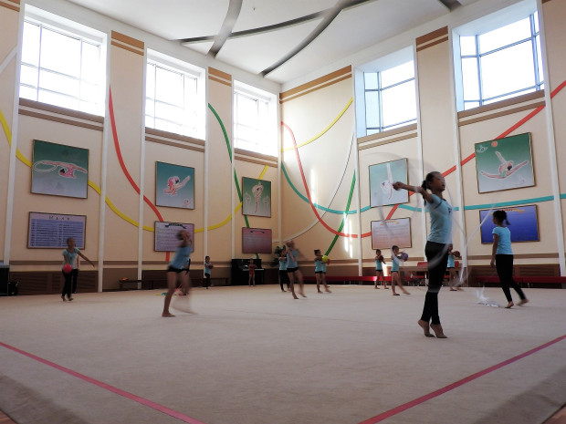
The Mangyongdae Children’s Palace in Pyongyang is a sprawling extra-curricular facility offering children lessons in sports, dance and music (Korean and non), foreign languages, science, computers, calligraphy and embroidery, and more. Around 5,000 children daily attend this facility. They may indeed be the most talented children in Pyongyang and surroundings, but encouraging the growth of talent is something done worldwide. Unlike in many Western nations, in the DPRK lessons are free of charge.

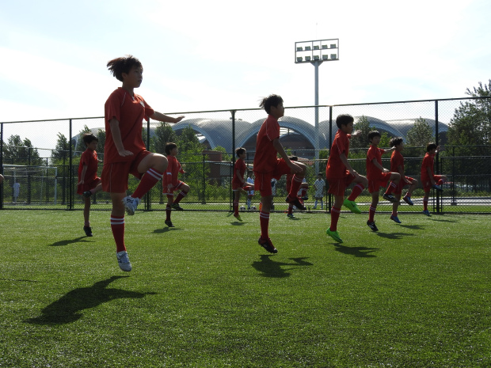
The Pyongyang International Football School opened in 2013. The complex includes a massive stadium and a school teaching all subjects, with football as a focus for the roughly 200 students. Different classes practiced their skills outside, doing warm-up drills to energetic music. When years ago I lived in Korea’s south, practicing Tae Kwan Do I warmed-up to similar drills.

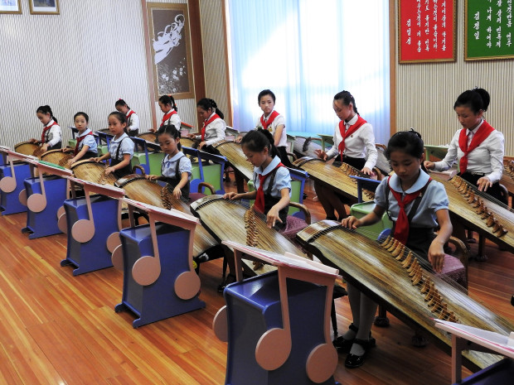
Students at the Mangyongdae Children’s Palace playing the traditional Korean instrument, the kayagun. Listen to their performance here.

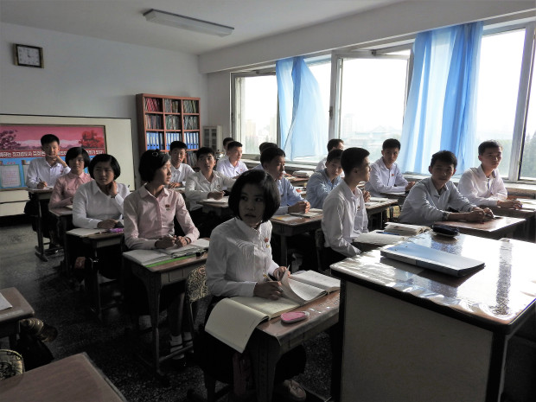
In Pyongyang Middle School. Students spoke in English of the universal desire for peace, one girl urging people to struggle for peace. On the issue of North Korea’s weapons, one teenage boy said: “We make intercontinental ballistic rockets, not for invading other countries but for our national defense. To protect one’s country, the country must have a powerful defense. To my questions about the U.S. sanctions, a girl replied: “The sanctions are not fair, our people have done nothing wrong to the USA.” Another boy spoke of the silence around America’s use of nuclear bombs on civilians: “Why do people all over the world give us sanctions? Why just us? Why can’t we put sanctions on the U.S.? It’s not fair, it’s totally wrong.”

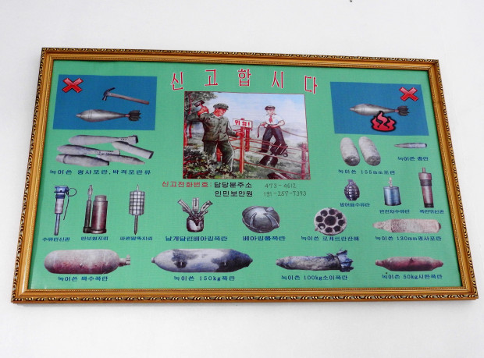
In a hallway in the Middle School, a poster encourages students to alert authorities if they come across unexploded ordnance (UXOs). Our host, Kim Song-Nam, said: “We’re still discovering old bombs, for example when we dig to lay the foundation for a building.” This article noted the discovery of nearly 400 UXOs near an elementary school playground, that farmers periodically come across UXOs, and that the cleanup period may take longer than 100 years. At the Pyongyang War Museum, we learned: “There were 400,000 people in Pyongyang, and they dropped more bombs than that on the city.” 428,000 bombs, according to the museum guide.

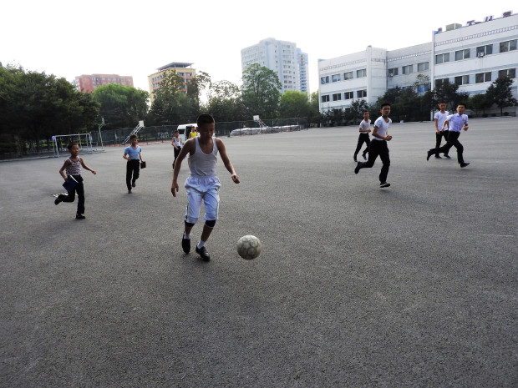
Students playing football outside the Middle School. Watch the clip here.

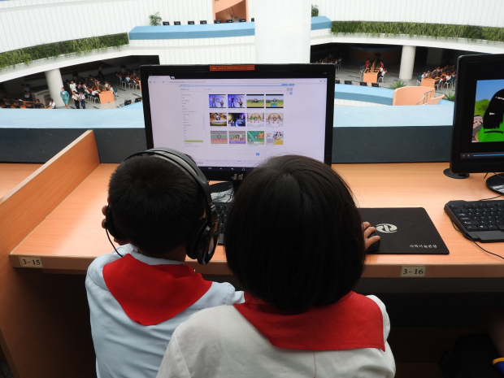
Pyongyang’s Science and Technology Center, completed in 2015, is an expansive structure heated by geothermal energy, and with drip irrigation-watered live grass on inside walls. Its more than 3,000 computers are solar powered, the library has books in 12 foreign languages, and a long-distance learning program enables people from around the country to study and earn a degree equivalent to that of in-university studies. Watch a tour of the center.

Student in the aquarium section of Pyongyang’s zoo. While the zoo was well-maintained, by far most interesting was watching the human interactions, from schoolchildren to adults. Koreans returned our smiles with deep, genuine smiles. Watch a clip from the zoo.

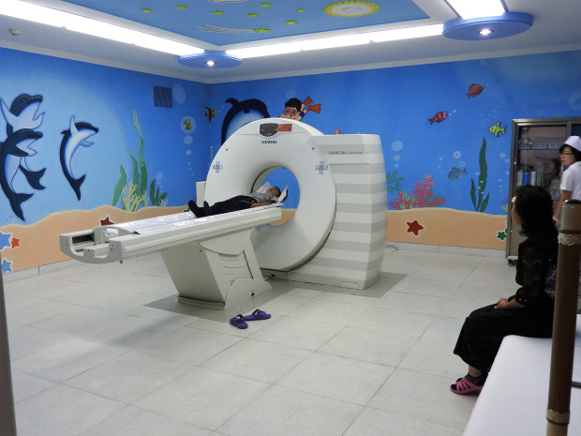
The Okryu Children’s Hospital is a six-story, 300-bed facility across from Pyongyang’s towering maternity hospital. U.S. sanctions on the DPRK prevent further entry of machines like the pictured CT scan. While defiantly proud of the health care system, Dr. Kim Un-Song spoke of her anger as a mother: “This is inhumane and against human rights. Medicine children need is under sanctions.”

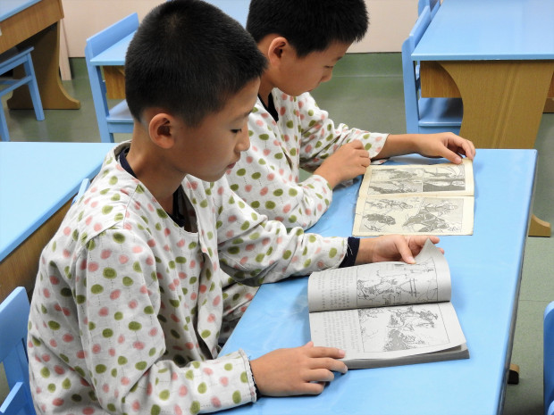
The Children’s Hospital provides classes to inpatient children to continue their studies while in hospital.

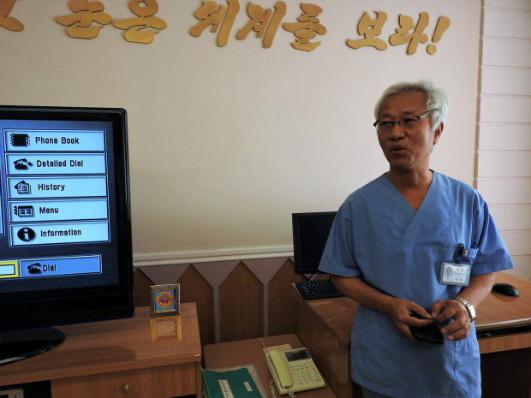
Dr. So-Yung (60) works in the tele-consultation department of the Children’s Hospital. “We have contacts with provincial-level and county-level hospitals, mostly about children’s diseases or illnesses. When they have difficulties with diagnoses, they request consultations from this hospital,” he explained. “I cannot suppress my anger about the sanctions imposed by the U.S. and other countries. Yet, generally, it doesn’t affect our health system. We have a solid health system, we are giving proper treatment to people and are producing our own medicines.”

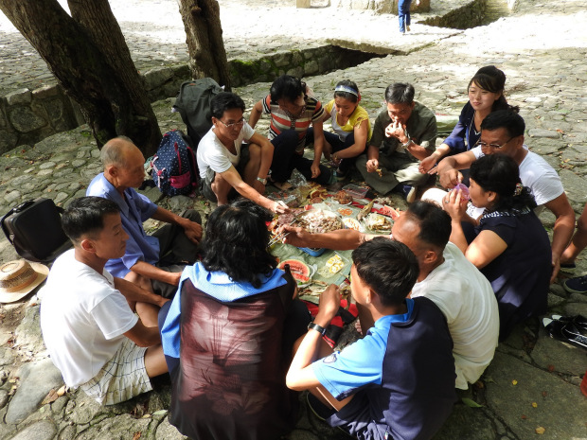
While walking up a path to the Pakyong Waterfall, over 100 km south of Pyongyang, I met a group of men and women grilling meat over a fire. At the waterfall, other picnickers ate grilled meat, fish, boiled eggs, kimbap (“Korean sushi”), and kimchi (fermented vegetables), drinking beer and soju (alcoholic drink). Having lived in South Korea, this scene is one I saw countless times along the sea or in the mountains. Watch clips here and here.

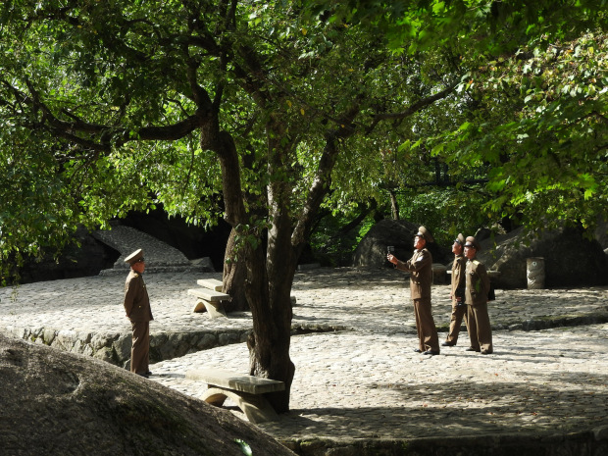
Beneath a tree near the waterfall, soldiers took turns being photographed with the waterfall as a backdrop. Later, they repeated at the waterfall. Watch here.

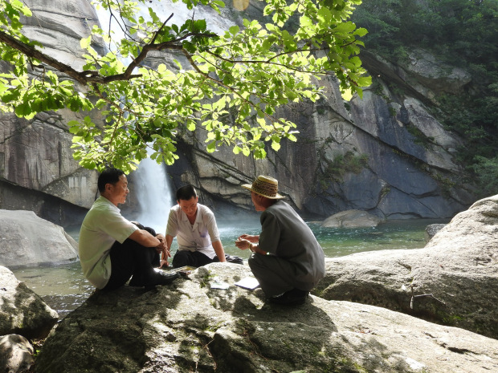
A group of men sit and chat near the base of the waterfall. Watch kids playing nearby here.

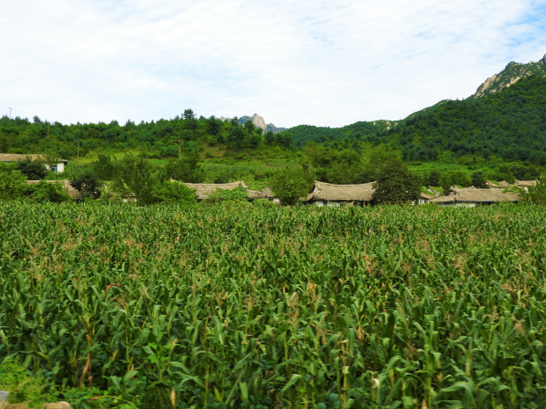
North Korea has suffered harsh periods of drought and starvation. The long-imposed brutal U.S. sanctions and destruction of the country don’t help matters. Yet, traveling over a hundred kilometers south from Pyongyang, we passed endless lush fields of corn and rice.

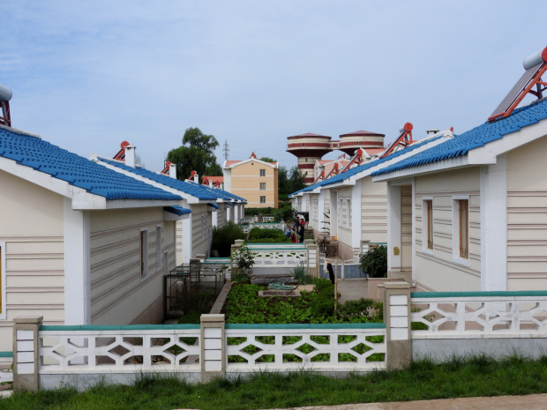
Plots of land surround houses in the Jangchon Cooperative Vegetable Farm. Homes are equipped with solar water heaters, and use methane gas for cooking. Song Myong-Oh moved with her husband from Kangnam county to the farm. Outside their home grew eggplants, peppers, corn, and herbs. Of America’s threats against North Korea she said: “Although we don’t want war, we are not afraid of the US.”

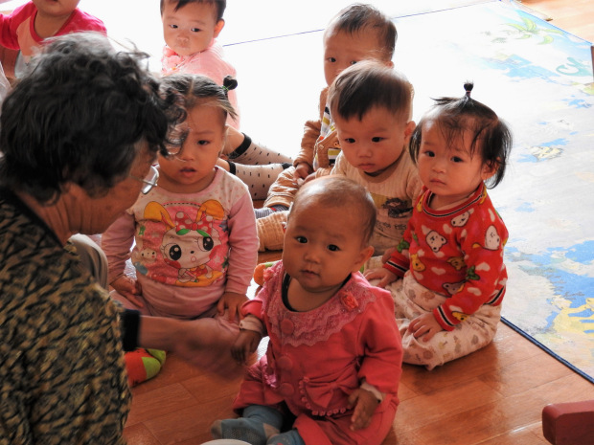
Inside the child-care center of the Jangchon Cooperative Farm. The cooperative also includes a cultural center for meetings and events, and rows of greenhouses.

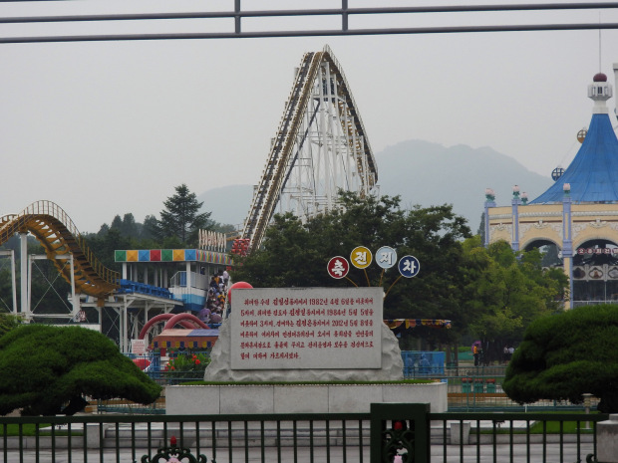
At the Kaeson Youth Amusement Park inside the city one night, I interacted with people and tried out some of the rides. The park was packed with families and children, including a group of 14-year-olds who had visited multiple times. A schoolteacher from Nampo City said she frequently brings her students to visit. A young man next to me on one of the rides filmed with his mobile. With an entrance fee of 200 North Korean Won (about US $0.22), the lines were long. Photo: A second amusement Park outside of Pyongyang.

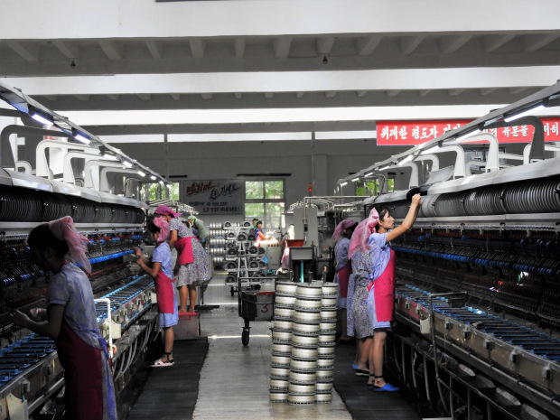
Under colonial Japanese rule, Pyongyang Silk Factory laborers worked in unsanitary conditions. When Korea gained independence, conditions were gradually modernized and improved. The present-day factory is clean and well lit, with water coolers throughout. The 1,600 workers work eight-hour shifts, with financial incentives to those who exceed their quotas. A nursery provides childcare, and unmarried women have accommodation on site, with a cafeteria and sports and leisure areas.

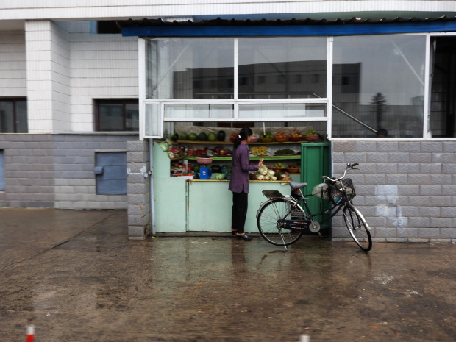
Fruit stand seen in Pyongyang. Small stands this size also sell snack food, sweets, water, sodas, beer, and ice cream.

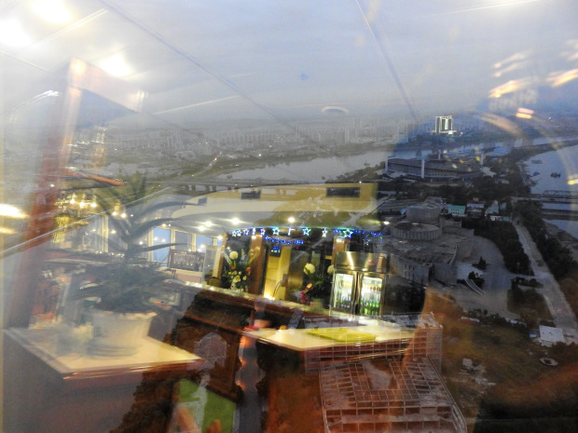
A revolving bar and restaurant at the top of Yanggakdo Hotel overlooks a modern, rebuilt city. The DPRK receives tourists from around the world — especially China and Japan, but also South Koreans — and is continually opening up areas for tourism. The potential for more American tourism was recently stymied with the September 1, 2017 U.S. travel ban.

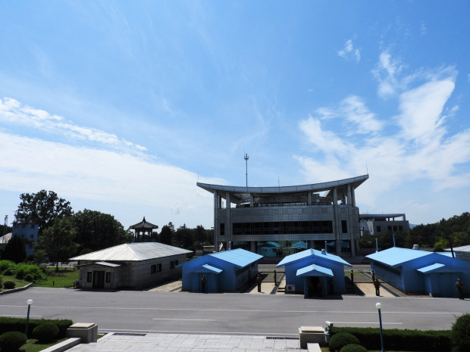
At Panmunjom, near the Demilitarized Zone (DMZ), one learns the North Korean side of history, including the over 8,400 ceasefire violations by the United States. One of many notable such violations was the espionage vessel, the USS Pueblo, now on display outside Pyongyang’s war museum. North Koreans on several occasions proposed to have peace treaty talks, with “no positive response from the U.S. side.”
This is something former U.S. President Jimmy Carter, who has visited the DPRK three times, confirmed — saying he had met with Kim Il-Sung in 1994 “in a time of crisis, when he agreed to put all their nuclear programs under strict supervision of the International Atomic Energy Agency and to seek mutual agreement with the United States on a permanent peace treaty, to have summit talks with the president of South Korea.” Carter maintained Kim Jong-Il pledged he would honor these promises.
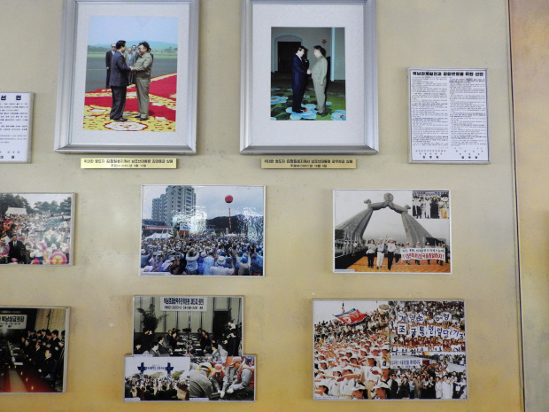
In a hall near the DMZ, photos depict 2000 and 2007 meetings between North and South discussing reunification, as well as the support of the people in both South and North. Our guide at Panmunjom noted: “On July 7, 1994, the day before he died, President Kim Il-Sung was looking through documents regarding reunification. He devoted his whole life to this.”

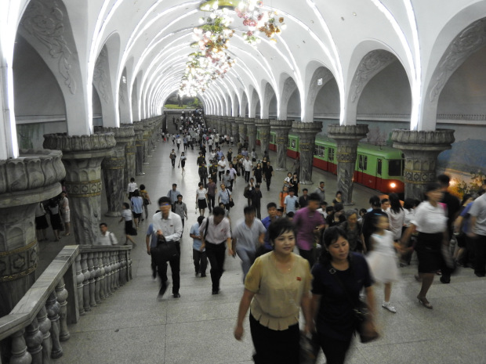
Pyongyang’s metro is a three-minute escalator ride below ground into a series of marble stations with elaborate chandeliers and beautiful wall paintings. Passengers ranged from well-dressed people, women in nice dresses and high heels, and others in casual blouses and slacks. Mosaics and engravings depict scenes of farming, construction, factories, rebuilding. Riding the metro costs the equivalent of a few cents. The tour group, Uri Tours, writes that half a million people ride the subway daily. Watch a clip of the metro here.

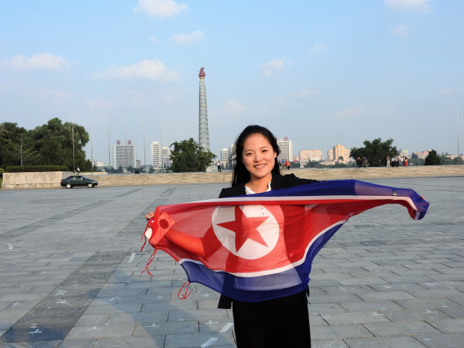
One of our hosts, Kim-Young, holding the flag of the DPRK. Behind her, the Juche tower, so-named after the dominant philosophy of self-reliance. Our other host, Kim Song-Nam, explained: “The Juche philosophy was created by President Kim Il-Sung. Man decides his own destiny, we rely on our own resources.”
Quelle : https://ingaza.wordpress.com/2017/10/28/photo-report-the-north-korea-neither-trump-nor-western-media-wants-the-world-to-see/

